ELECTRONIC BIDDING PROJECT
Business Case
(IT Project Authorization Request)
 | Author: | Carlos Alvarez | Sponsor: | Jay Bradley
 | Date: | March 15, 2004 | Version: | 2.0

 | Approvals:
 | Business Sponsor: | Jay Bradley, Procurement Manager
 |  | Name, Title Date
 |  | (The Project Sponsor is approving the contents of this IT Project Authorization Request, business justification for the project, and alignment with corporate strategy. The Project Sponsor is committing to deliver the benefits outlined in the justification.)
 | IT Lead: | Iván Pazmiño, IT Manager
 |  | Name, Title Date
 |  | (The IT Lead is approving the contents of this IT Project Authorization Request, alignment with corporate strategy and IT plans. The IT Lead’s focus is on the technical and architectural aspects of the project. The IT Lead is committing to deliver the IT resources to this project.)
 | Project Manager: | Jorge Chang, Contracts Coordinator  Alvaro Andrade, IT O&G Services Supervisor
 |  | Name, Title Date
 |  | (The Project Manager is signing off on the contents of the Project Authorization Request.)

1. Project Background 3
2. Project Definition 3
2.1. Project Objectives 3
2.2. Benefits 3
2.3. Scope 3
2.3.1. In Scope 3
2.3.2. Out of Scope 14
2.4. Assumptions 14
2.5. Uncertainties 15
2.6. Deliverables/Milestones 15
2.7. Project Measures of Success 15
2.8. Critical Success Factors 15
3. Risk Management 17
4. Resource Estimates 18

Project Background
Bidding process is applied manually inside procurement department. All activities are executed by Procurement department, but a lot of documents, proposal from vendors are generated in a un-structured way.
The issues of maintaining the confidentiality of the bid price, adherence to deadlines and validating the authenticity of bids might be problems, among others that needs to be resolved in the development of the electronic bidding system.

Project Definition

Project Objectives
The goal is to take the actual Bidding process to the Web, this shall allow Contractors to seamlessly view upcoming projects, download plans and specifications, prepare and submit the bid making it flexible, secure, real- time and electronically documented. When the electronic bidding system is implemented, the software packages to be adopted or developed shall allow the Contractor to download project bidding information, formulate their bid and submit the bid to a secure Web Site.

Benefits
Electronic Bidding is essentially a bidding process handled over the Internet. It is basically the same as a conventional bidding, but no paperwork is necessary. Receiving Bids via the Internet can make the bidding process more efficient, safe, and fair, with the help of electronic authentication and cryptographic technology. It will eliminate spatial and time constraints on both bidding and bidder.

Scope

In Scope

BUSINESS FUNCTIONS

The bidding application must consider the following activities as part of the bidding process:

- Offerer Management:

All pre-qualified vendors must be created to access the bidding application. All prospective bidders must request permission to submit electronic bids. This request shall be fulfilled with a written Agreement between the parties, in which all Contractors will accept the Internet site Terms and Conditions. No Contractor may use any part or portion of the Electronic Bidding process, without prior consent of Company. The detailed activities should be automatized.

- Offerer creation, update, delete. All offers are created with the following information:
  - Offerer Legal Name
  - Offerer services description
  - Address (Street, City, Province, Country)
  - Representative Name
  - Representative phone numbers
  - Representative email address
  - Additional comments
- An spreadsheet contains all pre-qualified vendors, this spreadsheet must be replaced with the new application. One superuser must be permission to create, update and delete, to be used for bidding process. The rest of departments should have access as read only.
- Big companies have some smaller companies inside. One account must be handled for each sub company to avoid issues between some biddings.
- A unique representative will be defined for the offerer. 2 o more representative are not allowed.
- Offerer account creation for access to application. One account is created and sent it to the representative of the company handle any bidding.
- Offerer will connect to the application from its offices using an internet connection, to execute all granted bidding process.
- Offerer grants must be managed as part of a profile managed by bidding administrator to access to specifics biddings.
- Offerer information must include the representative email to allow to send notifications of all bidding processing.
- A document agreement must be understood by all offerers about electronic bidding system policies

- Biddings creation

The bidding creation process includes the following activities

- A bidding is created with the following information:
  - Bidding Name
  - Bidding Description
  - Requestor department
  - AEC requestor contact
  - Clarification Date deadline
  - Offers Date deadline
  - Amount to decide minor or major tender board approval
- Each bid created must be assigned to the selected offerers. The Contracts coordinator will grant access for each offerer to the bid created.
- Offerers won’t have access to any bid by default. Permission will be assigned by bidding created to ensure that offerers won’t be able to access to unauthorized biddings
- A new login and password will be created for each new bidding. An electronic notification must be sent to the offerer representative with the new login and password to access to the specific bid. The first time that the representative access to the bid, it has to change the password.
- After a bidding process finishes, all login and passwords associated with the bidding must be deactivated automatically according the bidding deadlines.
- Each bidding includes pre-contract documents which will be requested by offerers. The following documents are mandatory:
  - Invitation Letter to offerers
  - Instructions to offerers document
  - Offer acceptance letter
  - Contract template

- The following documents are optional:
  - Technical specifications (several electronic files)
  - EHS Requirements
  - Maps and diagrams
  - Any not standard document
- A bidding creation must considerer to attach any future undefined document

- Bidding notification to offerers

The bidding notification process only can be executed after the bidding creation and grants assigned. It includes the following activities

- A process to send a notification by email, The application will select the granted offerers of the bidding to send the email to all representatives.
- Each notification should send the login and password for the new bidding process. The representative vendor should access to the application and change the login and password the first time.
- It must exists an option to send the notification several times
- Offerers representative will receive an email describing the bidding and referring to access to the application to review details and download pre-contract documents
- Offerer representatives will use the account to access to the application through Internet read the details, and download the pre-contract documents
- An audit logs registration should be available to allow to superusers application to confirm which offer downloaded the pre-contract documents.

- Clarification process

After the bidding notification all offerers have a limited time to request some clarification about the bidding process and details. It includes the following activities:
  - A representative will access to the application using the account through the Internet
  - The representative must use an option to submit a request for clarification
  - The clarification request must be sent only to the contracts coordinators
  - The contracts coordinator will clarify the question and he/she will publish the clarification in the application
  - A notification will be sent to all offerers announcing a new clarification posted in the bidding
  - The representative will access to the application to check the clarification posted by AEC Ecuador
  - After the clarification date deadline. Clarifications request will be disabled for the selected bidding.

- Offers reception

Offers reception is the process to receive all offers from vendors before the bidding deadline. It includes the following activities:

- Since the bidding was open, the vendors are able to upload purpose documents to the bidding using the account through the Internet.
- The request from departments for biddings process won’t be handled by the application.
- Vendors must be able to upload several versions of the purpose. To select the winner only, the last version will be considered. The previous version won’t be considerer
- After the vendors uploaded proposal documents, a reception notification web page should be showed to vendors. The vendors must have the option to print the reception notification to ensure that electronic bidding system has received the files successfully. This notification should contain:
  - Sent information
  - Attached files and its sizes
  - Last Modification dates
- After the vendor receives the reception notification, the vendor should have the option to perform a view of their uploaded documents. This option will allow to offereres to perform any kind of correction
- After the bidding date deadline (day, hours, minutes, and seconds define). Any offerer won’t be able to upload purposes
- After the bidding date deadline, a notification will be send only to the contract administrator to notify him, that a bidding process has been closed
- The contract coordinator will be able to open, download and print the purposes for the winner selection process.

- Tender Board Acceptance

A group of managers will insert a sign off which certifies that each person was present during the offers aperture. It includes the following criteria:

- The contract coordinator will meet all managers in one meeting
- He will download all purposes from the applications
- Each person will insert a sign off to certify his/her presence during the purposes opening
- A document with a list of assistants must be printed to certify the bidding processes for a bidding.

WORKFLOW

The following graphics illustrates the bidding process considerer for the application
Begin

Bidding Creation

No
Are Documents complete?

Yes

Offerer Repository
Bidding assignment to offerers & Notification

Clarification Request

Clarifications deadline
No

Yes

Offers Upload from Vendors

No
Bidding deadline
End

Yes
Notification to contract coordinator
Sign off process for purposes reception

SYSTEM INTERFACES

- English should be the default language
- A bilingual application is preferred (Spanish and English)
- It is required an application that can be accessed by vendors and offerers from their own IT Infrastructure.
- Company needs a public web site, totally secure and locked, in order to set up our electronic bidding system.
- Company shall be entitled to send and show information to specific bidders through the Internet, however it’s necessary to protect the information in order to avoid bidder intermission.
- Company shall post all the related documentation in the web (i.e. instruction to bidders, scope of services/technical specs, Contract project and others)
- The offers shall be received by deadline only and sent to a specific mailbox in order to proof receipt of each of them.
- There is not required any interface without any other software application. JDE interfaces for employees or vendors are not required.
- All offers will be loaded manually by application users.
- All pre-qualified vendors will be loaded manually by application users.

DATA MODEL

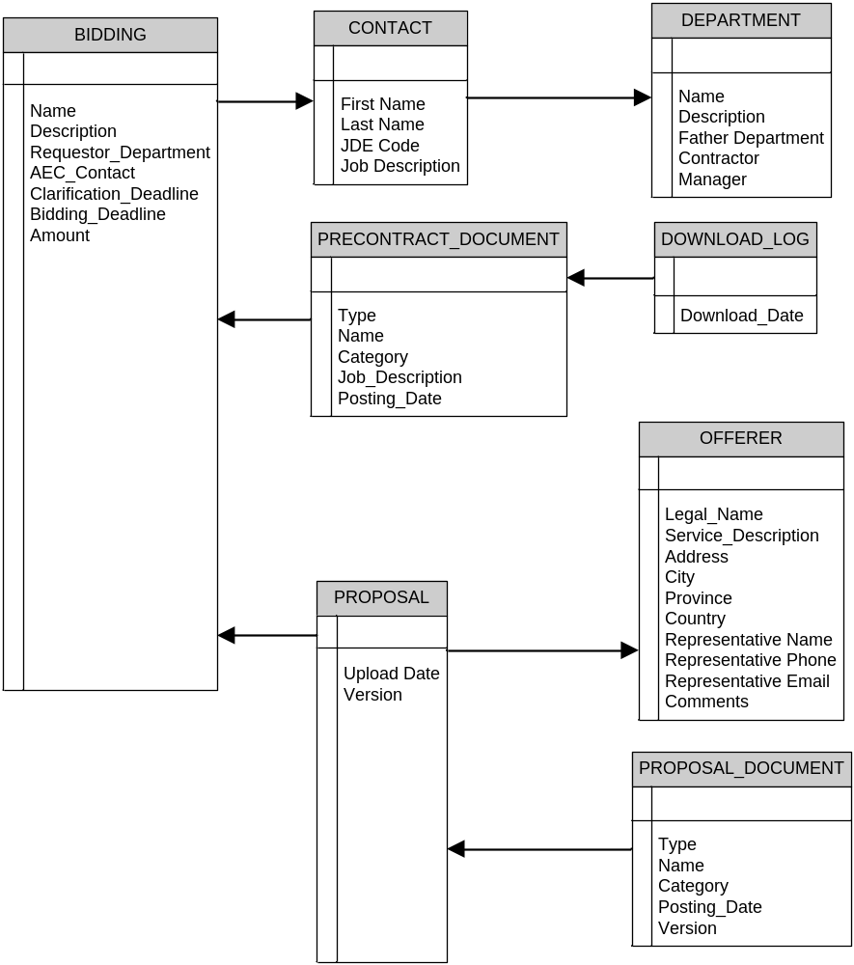

DEPARTMENTS – INTERNAL AND EXTERNAL

Procurement Department: Procurement will be the application superusers. The following usres have been defined:

- Jorge Chang (supersuserr)
- Manuel Romoleroux (review user)
- Jay Bradley (review user)

External Offerers: all vendor or company which can offer a purpose about a bidding process. All pre-qualifiied vendor can be an offerer.

DATA FILES

The electronic bidding process requires to handle the following type of files:

- Word
- Excel
- PDFs format
- Power Point
- Project
- Visio
- Autocad

The maximum size detected for a file could be 15 MB.

REPORTS

Some basic reports has been defined. Client has not defined specific reports format:

- Biddings by department for a date range
- Bidding by Offerer for a date range
- Bidding by status, and by department
- Bidding approved for a week

PROJECT PHASES TYPE OF WORK

1.- Project Authorization request
2.- Market Search to define possible vendors
3.- Deliver System Requirements to vendor
4.- Receive Proposal for Vendor
5.- Selection of vendor
6.- Project Charter and AFE Creation
7.- Project Kick Off
8.- Application Requirements analysis
9.- Application Development or Customization Phase
10.- Test environment installation
11.- Security environment Test (special)
12.- User acceptance
13.- Security Settings acceptance (special)
13.- User Training & Manual deliver
14.- Production environment installation

EXISTING SYSTEMS (CONVERSION)

There is not an automatic tool for managing bidding process. A spreadsheet contains all pre-qualified vendors. So it is necessary a manual migration from the spreadsheet to the new application.

- Pre-qualified vendors migration from spreadsheet. Users will load all pre-qualified vendors to the application. A responsible person should be defined in the future

PRELIMINARY IT INFRAESTRUCTURE REQUIREMENTS

A mixed architecture is required to handle public access and allow data protection. The following diagram show the possible components

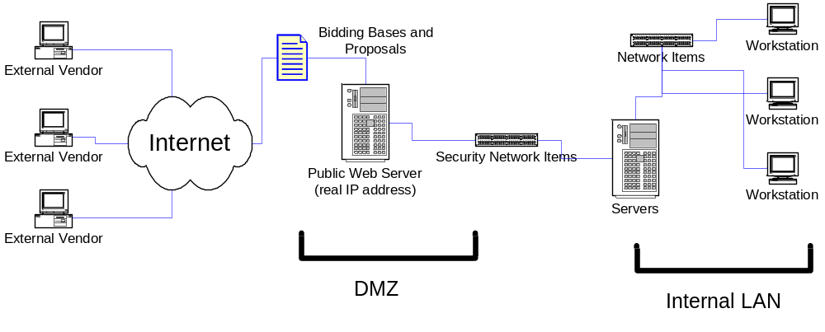

- A Web server is required to store Internet Web Pages
- A Database server is required to store Application Data
- A File Server is required to stored documents or applications must load documents and inside Database as Tables objects.
- Storage space must be considerer to plan future capacity requirements
- Security network items must be preserver according Encana Standards (firewalls, switches, routers, etc)
- A transaction control and certification application must be implement (Verysign)
- Any possible security holy should be considered and protected, because it is a risk for all corporation data
- An encryption tool should be included for transaction processing
- Identification, autentification, and authorization policies must be implemented to allow vendors to access to application
- Internal access should handle the internal Active directory autentification
- Database Standard is Oracle 8.1.7
- Web Server Standard is Internet Microsoft Internet Information Server 5.5
- It as mandatory at least 2 security levels.
- It is highly recommended 3 security levels:
  - IDENTIFICATION SECURITY LEVEL: The applications must handle an IP addresses range for each offerer. All offerers access must compare the authorized IP addresses vs. the IP addresses source to validate the access. If an access is performed by a host out of the authorized IP addresses range, this access must be locked and be rejected.
  - AUTENTIFICATION SECURITY LEVEL: The application must assign a login and password for each bidding process. For example if a vendor handles 5 bidding process, 5 accounts with different logins and password must be assigned. Only the representative will know login and password (password must be changed after the first logon)
  - CONFIRMATION SECURITY LEVEL: When a pre-contract document is downloaded, a clarification is requested or if a proposal document is uploaded, a electronic sign processes must be performed to confirm that the user is valid

POSSIBLE RESTRICTIONS:

- The vendor could require special database and web server standards, different from the Encana standards
- The selected application must implement the database and file environment inside Encana protected network. Only web pages can located in the public access. Web server can be located inside the DMZ (Demilitarized Zone)

Out of Scope

- Offerers pre-qualification process won’t be included in the electronic bidding application
- Automatic offerers selection to biddings won’t be handled by the application
- Technical and commercial evaluation process of any offer won’t he handled by the application
- Awarding letter to the bidding winner won’t be managed by the application. The contract coordinator will handle it manually.
- Any electronic or automatic notification to bidding winners won’t be handled
- Contract sign-off won’t be considered inside the application

Assumptions
The IT Infrastructure for the electronic bidding environment must have high standards security settings; however it must be located for public access through internet.

All vendors have a good quality internet connection to access to application
An e-commerce agreement must be accepted by AEC Ecuador and all vendors to access to the application.

Uncertainties
- Ecuador legal framework has changed in regards to electronic commerce and therefore still unknown specifics about electronic bidding in regards to regulatory requirements.
- Lack of experience in this type of systems brings uncertainty about what’s available in the market to fulfill functional requirements.
- To ensure High level security standards a special IT architecture might be required.
- Download and upload performance files could be a restriction for some vendors according their Internet connection.
- An exception manual process should be defined, formalized, put in place and published to the offers.

Deliverables/Milestones
Milestones | Target Date
Project Authorization Request Sign off | March 19, 2004
Market Search to define possible vendors | April 1, 2004
Selection of vendor | April 9, 2004
Project Charter Defined | April 10, 2004
AFE Creation | April 25, 2004

Project Measures of Success
Measure | How | By Whom
Package selected which meet all functional requirements | Check process to compare functional requirements vs. implemented package features | Contract Coordinator, Procurement Manager
Starts conducting bidding process electronically | Facilities bidding process will be processed in an electronic way | Contract Coordinator, Procurement Manager, IT Manager

Critical Success Factors
User participation: User must be present in all development phases to ensure to get system requirements implemented

Security Schema: A security schema to protect all documents against unauthorized access must be high reliable

Encana standards compliance: All Encana Standards must be kept to access to all security protection configuration

Risk Management

`Risk # | Risk Factor/Impact | Impact Severity |  |  | Probability |  |  | Risk Rank | Mitigation Plan
 |  | 1  low | 2  med | 3  high | 1  low | 2 med | 3  high | See  Note #1
 | Vendors won’t fulfill functional requirements |  | X |  |  | X |  | 4 | To develop a new application with local vendors
 | Security Architecture does not compliance Encana standards |  |  | X |  | X |  | 6 | Define a security architecture with all IT staff and with Calgary suggestion
 | Unauthorized access can produce data losts. |  |  | X | X |  |  | 3 | Define a high level security configuration
 | Transactions not certified can be inserted into the application |  | X |  |  | X |  | 4 | Define an automatic tool to certify transactions in the Internet
5. | Ecuador legal framework does not allow electronic bidding |  | X |  |  | X |  | 4 | Search for Semi automated solutions

(Notes:
- The Risk Rank is a synthesis of impact and probability. It is the multiplication of Severity X Probability.
(e.g. if severity is 3 and probability is 2 then the ranking is 3 X 2 = 6)

- If the mitigation plan cannot reduce risk adequately, a contingency plan should be drawn up.)

Resource Estimates

(Note that at this stage in the project, we can only make our best guess at what the costs will be. It is expected that the estimates should be in the + or – 50% range.)

Effort in Person Days | Business | IT | Consultant | Total
Manpower |  | 10000 |  | 10000
Budget ($)
External Manpower
Software |  |  | 70000 | 70000 (*)
Hardware |  | 20000 |  | 20000
Travel, Training, Other | 10000 |  |  | 10000
Contingency | 10000 |  |  | 10000
TOTAL |  |  |  | 120000

(*) Estimation to be further evaluated on market research project phase.

